Information for HealthCare Providers wishing to send CareConnect eReferrals

Facility HPI/Organisation ID
All Health Providers completing eReferrals need to be associated with the physical address where the health care takes place with a facility HPI (6 digit alphanumeric organisation Id e.g. F2G123). An Organisation ID is a mandatory field in order to send a CareConnect eReferral.

If you need help finding your Organisation’s Facility HPI:
- Go to the MOH’s Facility Code webpage
- Download the latest facility code table spreadsheet
- Find your Organisation’s “HPI Facility Id”

If you do not have a Facility HPI, you will need to register here for one through the MOH
Requests for or queries about facilities and their identifiers should be sent to
HI_Provider@moh.govt.nz

HealthSecure Digital Certificate
A HealthSecure Certificate is required to provide user authentication to send Web eReferrals. (Making the information ‘safe’)

It is best practice to have one HealthSecure certificate per provider. But for web eReferrals you only require ONE certificate per organisation.

The certificate will technically belong to one person (either one of the HealthCare providers or an administrator).

Please note that it is the responsibility of the owner of the certificate to grant access for their health providers to use their Certificate and monitor correct use.

Follow Option B

NHI Look-up OPTIONAL
All patients being referred using CareConnect eReferrals require a valid NHI number. NHI look-up is a tool to check NHI numbers. .

You do not need NHI Look-up to be able to start using the service and it is completely your organisation’s decision as to whether you think you will have a significant number of NHI’s to confirm and wish to complete the HealthLink application process.

If your organisation does not have the ability to look up NHIs and they wish to do so, please Follow Option C (which also covers getting a digital certificate if you require one.)

Process to follow to get access to CareConnect eReferrals:

Option A – if you have MedTech32, MyPractice or Profile for Mac Practice Management System

Contact Healthlink HelpdeskHL@healthlink.net and get yourself and the system set up to send eReferrals directly from the System

Option B – if you do not have one of the above Practice Management Systems and also do not wish to look up NHIs

- If you do not have a current digital certificate, go to the MOH website (Information about obtaining a digital certificate). BOTH forms must be fully completed please.

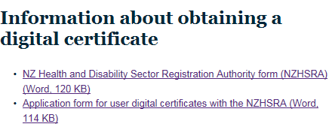

Please note: For this project please enter eReferrals in the “Other” field Section 5 as shown below. The other tick boxes are NOT relevant to CareConnect eReferrals .

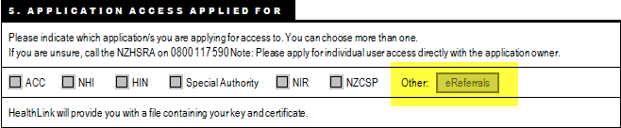

Please send the two completed original forms to the NZ HealthSecure Registration Authority.
Email to: registrar@nzhsra.co.nz
Or Mail to:
NZHSRA
P O BOX 30823
LOWER HUTT 5040

- Complete and send attached Healthlink Registration form
  - Form can also be found here
  - Send to myhealthlink@healthlink.net

Option C - if you do not have one of the above Practice Management Systems, Require the ability to lookup NHIs (NHI Lookup) and may also require a HealthSecure Digital Certificate

- Register for HealthLink NHI Lookup here http://www.healthlink.net/nhiservice.asp
Please enter “eReferrals” in the additional comments field so we know not to charge you.

- HealthLink will send you a letter of all the documentation you need to complete and you need return this to HealthLink before we can seek MoH approval to activate your connection.

After you return your application to HealthLink, please continue with the following steps so that you may get set up to start sending CareConnect Web eReferrals while you wait for activation of your NHI Look-up connection (four plus weeks)

- Access to the NHI facility and using CareConnect Web Referrals require you to have a HealthSecure Digital Certificate. If you do not have one please contact the Registration Authority on 0800 117 590 and let them know that you have applied for HealthLink NHI Look-up.

- Complete and send attached Healthlink Registration form for CareConnect
a. Form can also be found here
b. Send to myhealthlink@healthlink.net

